Privacy policy link:
https://app.termly.io/dashboard/website/4a2a4676-fc53-4807-af71-13e4b89d6834/privacy-policy

Admob keys
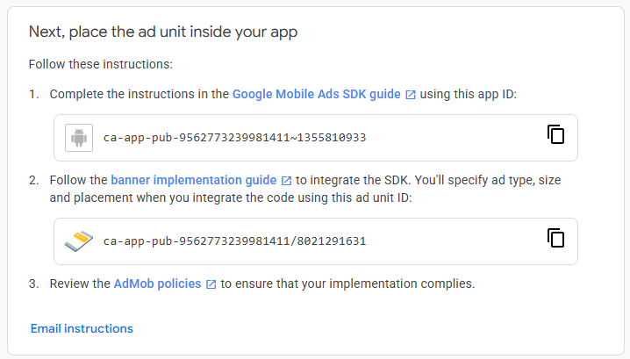

Changes to the UI:
- Initial set up should be introduced by giving a brief description of the app’s purpose, then asking for the information needed in Settings. Add a note “You can always change this in Settings”
- Currently the settings that are saved are not translating to the info displayed and accessed for the fuel calculations. Update the code so the settings are updated.
- The main page of the app should have a map preview showing the user’s location, and the “Find cheapest fuel button”.
- Once that button is pressed the results page should remove the vehicle info/settings banner and the find fuel button. The page should default to the List view, including as many fuel stations that fit without being squished. If a station is pressed, it should display a pop up with calculation data and a “Navigate to” button.
- In the Map tab of the results, add a colour code tab for the closest station that is used to compare the cheapest fuel to

